Original Article Title
Author Name¹, Author Name², Author Name³…
ABSTRACT

BACKGROUND.
The point of the research – why should we care about the study? This is usually a statement of the BIG problem that the research helps to solve and the strategy for helping to solve it. It prepares the reader to understand the specific research question.
OBJECTIVES
The specific research question – the basis of credible science. To be clear, complete and concise, research questions are stated in terms of relationships between the variables that were investigated. Such specific research questions tie the story together – they focus on credible science.
METHODS
A precise description of the methods used to collect data and determine the relationships between the variables.
RESULTS
The major findings – not only data, but the RELATIONSHIPS found that lead to the answer. Results should generally be reported in the past tense but the authors’ interpretation of the factual findings is in the present tense – it reports the authors’ belief of how the world IS. Of course, in a pilot study such as the following example, the authors cannot yet present definitive answers, which they indicate by using the words “suggest” and “may”.
CONCLUSIONS
The consequences of the answers – the value of the work. This element relates directly back to the big problem: how the study helps to solve the problem, and it also points to the next step in research.
KEYWORDS
Key words or phrases in alphabetical order; separated by semicolon.

BACKGROUND

E
xplain why the study was needed and specify your research objectives or the question(s) you aimed to answer. Start from more general issues and gradually focus on your research question(s). If possible, formulate the hypothesis you tested.
METHODS
Describe in detail how the study was carried out (e.g., study area, data collection, criteria, origin of analyzed material, sample size, number of measurements, age and sex of participants or tissue/cell donors, equipment, data analysis, statistical tests, and software used). All factors that could have affected the results need to be considered. Sources of experimental materials obtained from biobanks should be mentioned with full names and identifiers, if available (Bravo et al 2015). If you cite a method described in a non-English or inaccessible publication, explain it in detail in your manuscript. Make sure that you comply with the ethical standards (eg WMA 2013) in respect of patient rights, animal testing, environmental protection, etc.
RESULTS
Present the new results of your study (usually published data should not be included in this section). All tables and figures must be mentioned in the main body of the article, and numbered in the order in which they appear in the text. Make sure that the statistical analysis is appropriate (eg Habibzadeh 2013). Data on humans, animals or any material originating from humans or animals, should be disaggregated by sex. Do not fabricate or distort any data, and do not exclude any important data; similarly, do not manipulate images to make a false impression on readers. Such data manipulations may constitute scientific fraud.
Figures and Tables
Place figure captions above the figures in 8pt regular font. If figure has two parts, include the labels “(A)” and “(B)” as part of the artwork.

Use the abbreviation “Fig.” even at the beginning of a sentence.

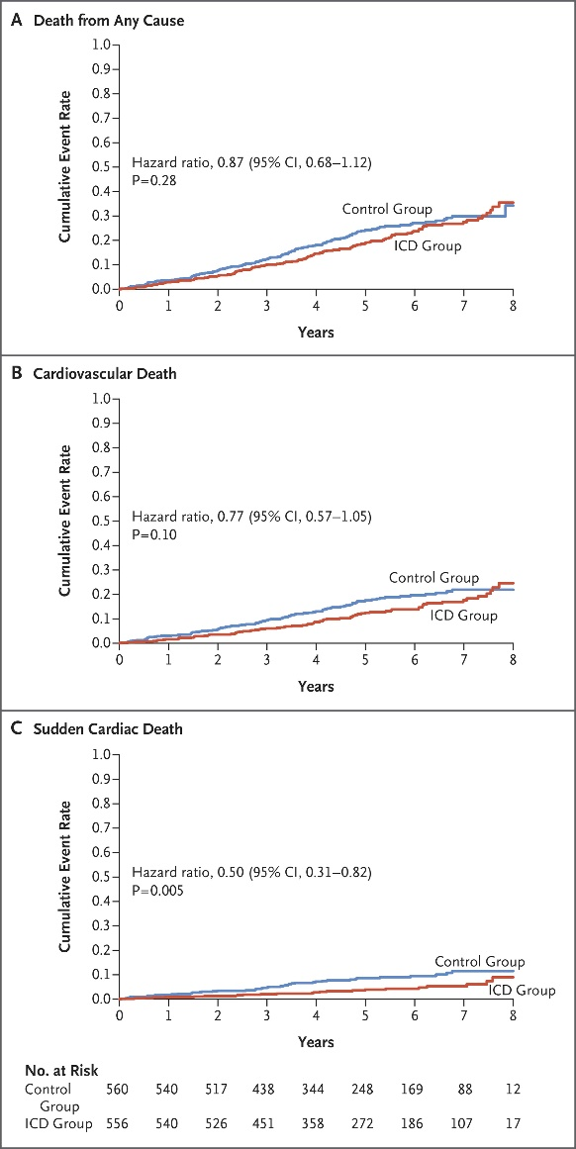

FIGURE 1. Example of the figure caption

Place table titles above the tables in 8pt regular font.

Please verify that the figures and tables you mention in the text actually exist.

If the size of Figure or Table is more than the column size, the same may be adjusted in single column format without disturbing rest of the content.

TABLE 1. Example of table styles

 | Table Column Head
 | Subhead | Subhead | Subhead
1
2
3
4
5
Other recommendations
- SI units are strongly encouraged.
- Use one space after periods and colons;
- Use a zero before decimal points: “0.25,” not “.25.”;
- Use “cm3,” not “cc.”;
- Indicate sample dimensions as “0.1 cm x 0.2 cm,” not “0.1 x 0.2 cm2.”
- Do not mix complete spellings and abbreviations of units: use “kg/m²” or “kilograms per square meter,” not “kilograms/m².”
- When expressing a range of values, write “2 to 7” or “2-7,” not “2~7.”
- A periods and commas must be within quotation marks, like “this period.” Other punctuation must be “outside”!
- Avoid contractions; for example, write “do not” instead of “don’t.”
- The serial comma is preferred: “A, B, and C” instead of “A, B and C.”
DISCUSSION
This section is not the place to present new results, including statistical results. Answer your research questions (stated at the end of the Introduction) and compare your main results with published data, as objectively as possible. Discuss their limitations and highlight your main findings. If your study included subjects of one sex, discuss the implications and potential to generalize your findings for both sexes. Consider any findings that run contrary to your point of view. To support your position, use only methodologically sound evidence (Roig 2015). At the end of the Discussion or in a separate section, emphasize your major conclusions and the practical significance of your study.
AUTHOR AFFILIATION
A "byline" or "affiliation" is an acknowledgment of the organization that has supported you to conduct your research, and should be recorded on the published version of your output.
SUPPLEMENTARY MATERIALS
Supplementary material is relevant material that is additional to the main article. It can be anything from tables to presentations, to video and audio files.

These supplementary materials add another dimension to your article, and help with increasing its online reach and broadening the scope of its impact within your discipline.

Research shows that articles with supplementary material are downloaded and cited more often than those without. By including data and supporting materials to your article, researchers can access your work more easily. Funders are also able to identify clear links to data, making sure you meet your certain funding requirements.
Types of supplementary material
- Infographics - You can summarize your findings and attract readers to your article by including an infographic, alongside your article;
- Tables and charts - Include the full range of data and statistics from your research without over-cluttering your article;
- Video - Engage your audience and deliver the main points of your article across to your audience with multimedia;
- Audio - Consider adding relevant audio files to enhance your readers’ understanding and engagement with your research.
ACKNOWLEDGEMENTS
Mention all people who contributed substantially to the study but cannot be regarded as co-authors, and acknowledge all sources of funding. The recommended form is: “This work; was supported by the Medical Research Council [grant number xxxx]”. If no specific funding was provided, use the following sentence: “This research received no specific grant from any funding agency in the public, commercial, or not-for-profit sectors.” (RIN 2008). If relevant, disclose to the editors any other conflicts of interest, e.g., financial or personal links with the manufacturer or with an organization that has an interest in the submitted manuscript (Goozner et al 2009). If you reproduce previously published materials (e.g., figures), ask the copyright owners for permission and mention them in the captions or in the acknowledgements. If you were helped by a language professional (e.g., author’s editor or translator), a statistician, data collectors, etc., you should acknowledge their assistance for the sake of transparency (ICMJE 2017, Battisti et al 2015). It must be clear that they are not responsible for the final version of the article. You need to ensure you have the consent of all the people named in this section.
REFERENCES
Make sure that you have provided sources for all information extracted from other publications. In the list of references, include all data necessary to find them in a library or in the Internet. For non-English publications, give the original title (transliterated according to English rules if necessary), wherever possible followed by its translation into English in square brackets (CSE 2014). Avoid citing inaccessible, coercive and irrelevant references. Wherever appropriate, cite primary research articles instead of reviews (DORA 2013). Do not include unpublished data in the list of references – if you must mention them, describe their source in the main body of the article, and obtain permission from the producer of the data to cite them.

The American Medical Association (AMA) citation style is strongly encouraged.
AMA in-text citation
Example: As suggested by Nandita,1 carpal tunnel syndrome can also result from …
AMA book citation
Format: Author last name Initials. Book Title: Subtitle. Publisher; Year.
Example:
- Conrad P, Gallagher EB. Health and Health Care in Developing Countries: Sociological Perspectives. Temple University Press; 1993.
AMA journal citation
Format: Author last name Initials. Article title. Journal Name. Year;Volume(Issue):Page range. DOI or URL.
Example:
- Conrad P, Gallagher EB. Health and Health Care in Developing Countries: Sociological Perspectives. Temple University Press; 1993.
AMA website citation
Format: Author last name Initials. Page title. Website Name. Published Month Day, Year. Accessed Month Day, Year. URL.
Example:
- Murphy B. 5 tips to survive first-year anatomy lessons in medical school. American Medical Association. Published August 24, 2022. Accessed September 2, 2022. https://www.ama-assn.org/medical-students/medical-school-life/5-tips-survive-first-year-anatomy-lessons-medical-school.

